February 18, 2022

*Via E-mail:* <<ADJUSTER_EMAIL>>

<<INSURANCECOMPANY_SUITNAME>>

c/o Claims Department

***RE: Pre-litigation Notice and Settlement Demand***

**Insured:** <<INJUREDPARTY_NAME>>

**Property Address:** <<INJUREDPARTY_FULL_ADDRESS>>

**Claim No.:** <<INS_CLAIM_NUMBER>>

**Date of Loss:** <<ACCIDENT_DATE>>

**Our File No:** <<CASE_ID>>

To whom it may concern:

Please allow this correspondence to serve as our letter of representation of, <<PROVIDER_SUITNAME>>, request for a copy of the subject policy of insurance and its pre-suit demand letter as required by section 627.7152(9)(a). <<PROVIDER_SUITNAME>> hereby places <<INSURANCECOMPANY_SUITNAME>> on notice that it intends to initiate litigation. A copy of this letter is being sent to the insured.

**Damages in Dispute:** $<<BALANCE_AMOUNT>>

**Amount Claimed:** $<<BALANCE_AMOUNT>>

**Pre-Suit Demand:** $<<BALANCE_AMOUNT>>

<<PROVIDER_SUITNAME>> demands full payment of the pre-suit demand in order to prevent the initiation of litigation regarding the above-referenced claim. Please mail all checks to our office payable to our Trust Account, or to the Provider and our firm.

Sincerely,

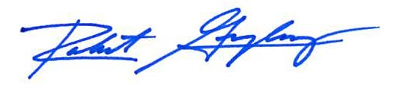

Robert F. Gonzalez, Esq.

Enclosures